TASK 3: WEB APPLICATION SECURITY
1. Introduction
Web application security is the practice of protecting web applications from vulnerabilities that can be exploited by attackers. During this task, a controlled web security testing environment was created using Damn Vulnerable Web Application (DVWA) on Kali Linux. DVWA is an intentionally vulnerable web application designed for learning and practicing web application security testing techniques.
The objective of this task was to understand common web application vulnerabilities, demonstrate their impact in a controlled environment, and analyze the security measures that can be used to prevent them. The practical exercises covered SQL Injection, Stored Cross-Site Scripting (XSS), Reflected Cross-Site Scripting (XSS), Cross-Site Request Forgery (CSRF), Local File Inclusion (LFI), and web security headers.
All testing was performed locally on the Kali Linux system against the intentionally vulnerable DVWA application.

2. Objectives
The main objectives of this task were:
- To understand common web application security vulnerabilities.
- To install and configure DVWA in a controlled Kali Linux environment.
- To demonstrate SQL Injection and understand its security impact.
- To demonstrate Stored and Reflected Cross-Site Scripting (XSS).
- To understand and demonstrate Cross-Site Request Forgery (CSRF).
- To demonstrate Local File Inclusion (LFI).
- To analyze HTTP response security headers.
- To understand the importance of secure coding practices and web application security controls.
- To gain practical experience in identifying vulnerabilities using a controlled testing environment.

3. Environment and Tools
The following environment and tools were used during the practical implementation:
Component | Details
Operating System | Kali Linux
Web Server | Apache2
Database Server | MariaDB
Programming Environment | PHP
Vulnerable Web Application | DVWA
Web Browser | Firefox
Security Testing Tool | Burp Suite Community Edition
Testing Environment | Localhost / 127.0.0.1
The entire practical environment was configured locally to ensure that all security testing activities were performed in a controlled and authorized environment.

4. DVWA Installation and Configuration
Damn Vulnerable Web Application (DVWA) was installed and configured on Kali Linux as the target application for the web security exercises. Apache2 was configured as the web server and MariaDB was used as the database server.
The DVWA application was placed in the Apache web directory and its database configuration was completed. The DVWA database and required database user were configured in MariaDB. After successful configuration, the DVWA setup page was accessed through the local web server.
The application was configured to Low security level for demonstrating vulnerabilities in a controlled educational environment.
The DVWA application was successfully accessed through the local address:
http://127.0.0.1/dvwa/

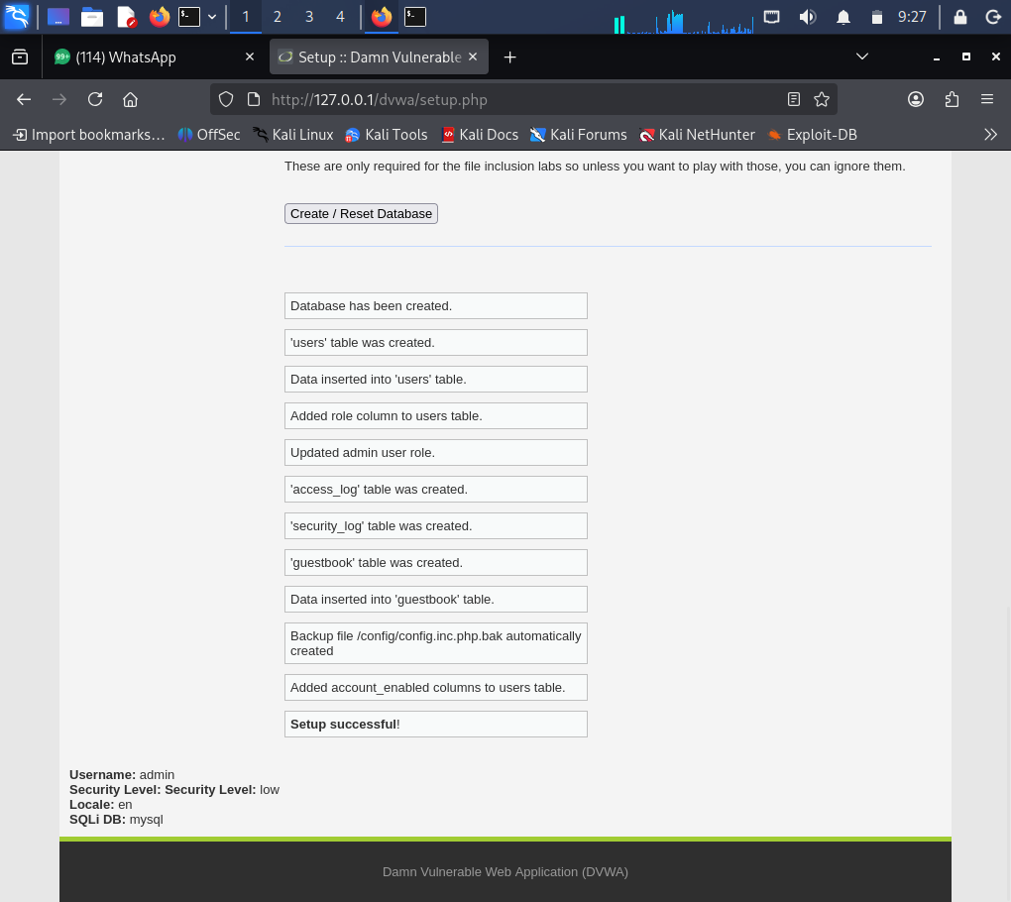
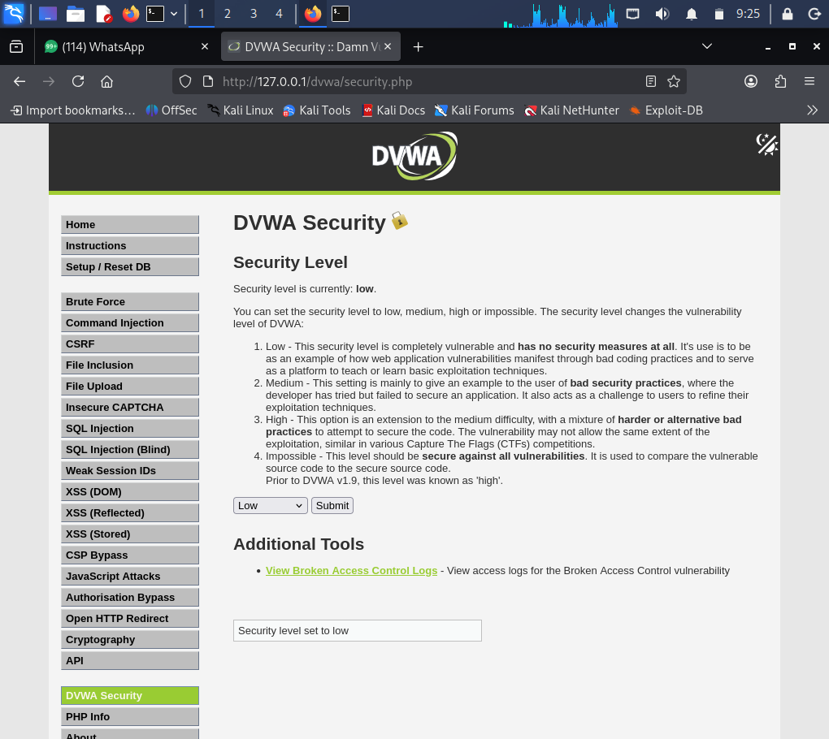

5. SQL Injection
SQL Injection is a web application vulnerability that occurs when untrusted user input is incorporated directly into an SQL query without proper validation or parameterization. An attacker may manipulate the input to alter the intended SQL query and retrieve unauthorized information.
For this demonstration, the SQL Injection module of DVWA was used with the security level set to Low.
Normal Input
A normal user ID value of 1 was entered into the User ID field. The application returned the corresponding user record.
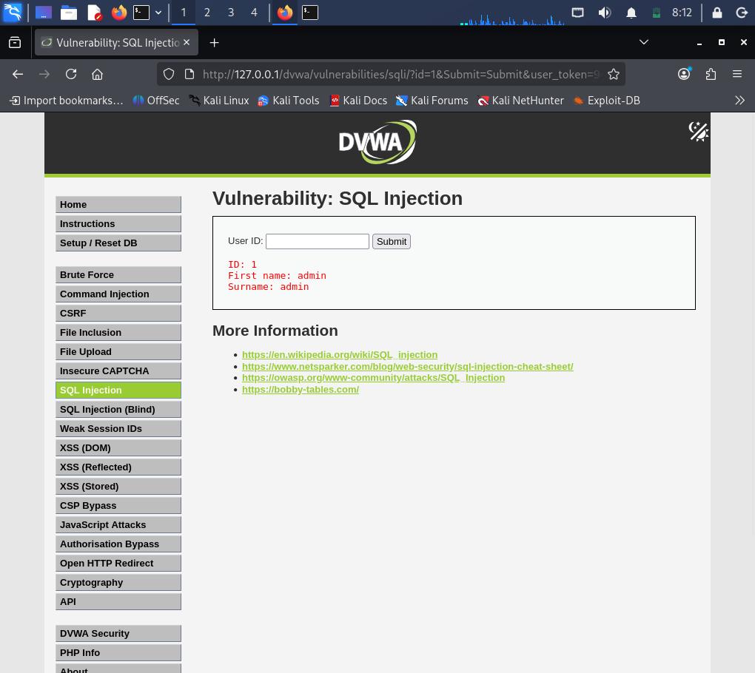
SQL Injection Test
The following controlled test input was entered:
1' OR '1'='1
The application returned multiple records, demonstrating that the user input was being interpreted as part of the SQL query.
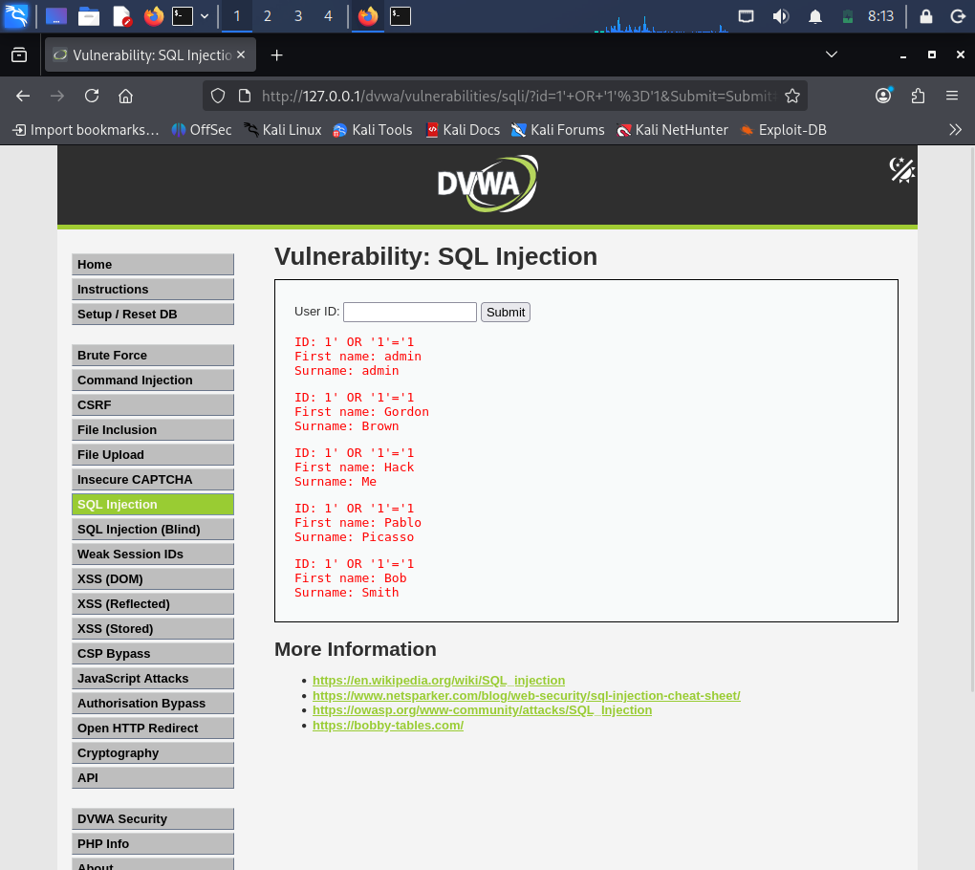
Result
The demonstration showed how improper handling of user-supplied input can allow an attacker to manipulate database queries and retrieve unintended records.
Mitigation
SQL Injection can be prevented by using prepared statements and parameterized queries instead of directly concatenating user input into SQL statements. Input validation, least-privilege database accounts, and secure error handling should also be implemented.

6. Stored Cross-Site Scripting (Stored XSS)
Stored Cross-Site Scripting is a vulnerability in which malicious client-side script is permanently stored by a web application and later executed when another user views the affected content.
The Stored XSS module in DVWA was used for the demonstration. A controlled JavaScript payload was submitted in the message field:
<script>alert('XSS Test')</script>
After submitting the entry, the JavaScript executed in the browser and displayed an alert message. Since the content was stored and subsequently executed when displayed, the demonstration confirmed the presence of Stored XSS.
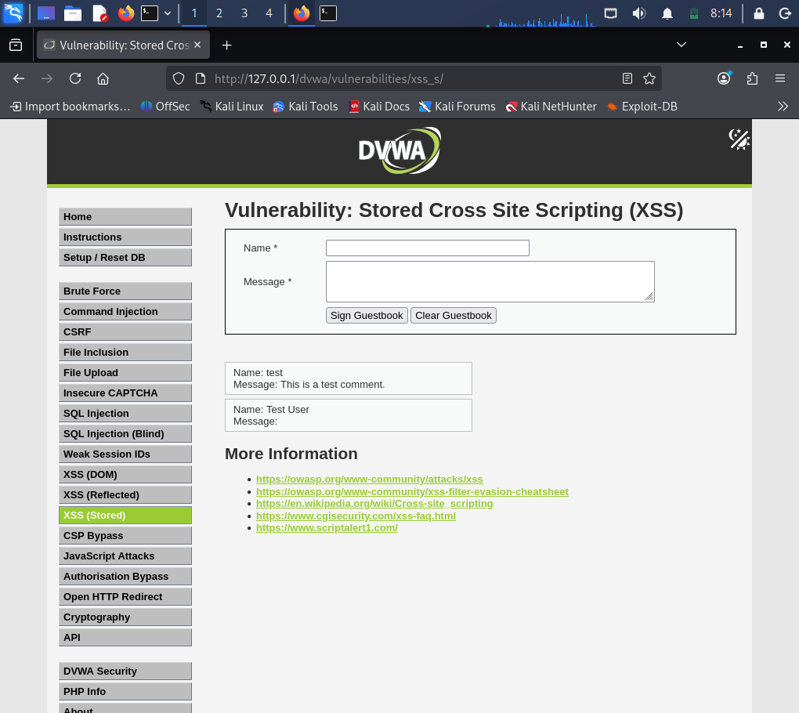
Mitigation
Stored XSS can be mitigated through proper output encoding, input validation, HTML sanitization, secure templating mechanisms, and Content Security Policy (CSP). User-supplied content should never be directly rendered as executable HTML or JavaScript.

7. Reflected Cross-Site Scripting (Reflected XSS)
Reflected XSS occurs when user-supplied input is immediately reflected by the web application in its response without proper sanitization or output encoding.
The Reflected XSS module of DVWA was used for testing. A controlled JavaScript payload was entered into the input field:
<script>alert('XSS Test')</script>
The application reflected the supplied input in its response, and the JavaScript executed in the browser, producing an alert.
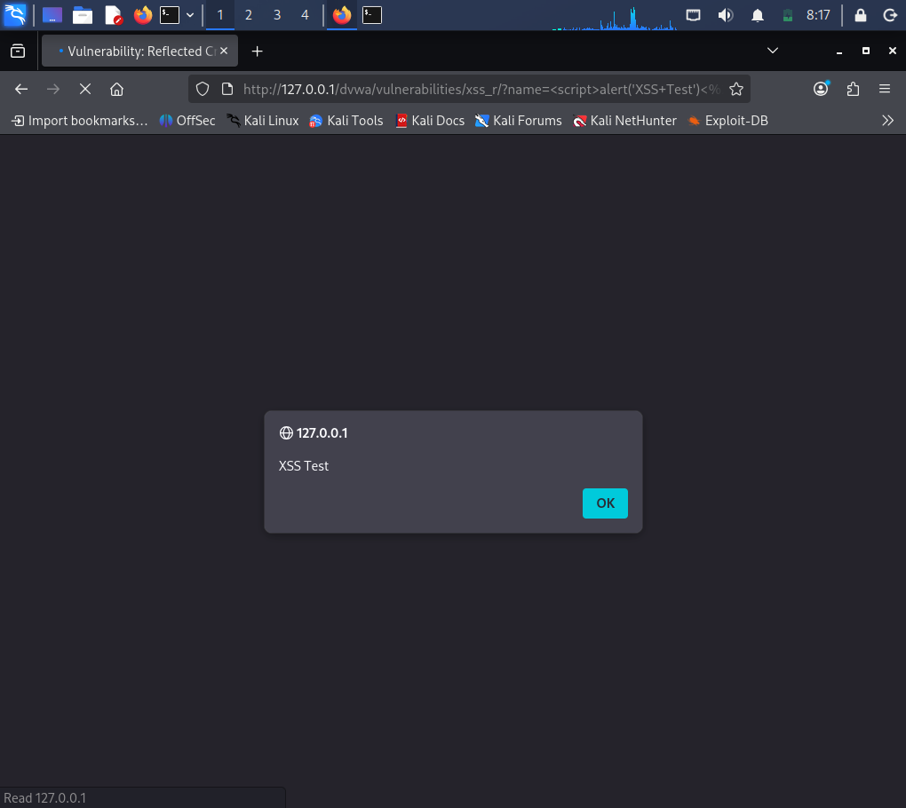
Mitigation
Reflected XSS can be prevented through server-side input validation, context-aware output encoding, HTML sanitization, and Content Security Policy (CSP). Applications should treat all user-controlled input as untrusted data.

8. Cross-Site Request Forgery (CSRF)
Cross-Site Request Forgery is a vulnerability in which an attacker attempts to cause an authenticated user's browser to perform an unwanted action on a web application.
The CSRF module in DVWA was used to understand the password-change functionality. A new password was entered into the password and confirmation fields and the password-change operation was successfully performed in the controlled DVWA environment.
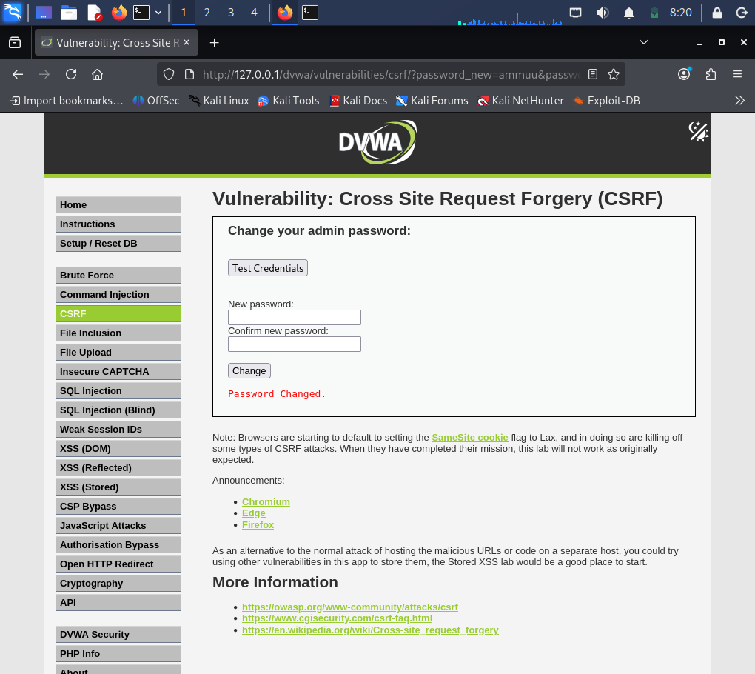
Security Impact
If a sensitive operation does not verify that the request was intentionally generated by the authenticated user, an attacker may potentially cause unauthorized actions to be performed using the victim's active session.
Mitigation
CSRF can be mitigated by implementing unpredictable, session-specific anti-CSRF tokens and validating the token on every state-changing request. SameSite cookie attributes and appropriate origin/referrer validation can provide additional protection.

9. Local File Inclusion (LFI)
Local File Inclusion is a vulnerability that occurs when a web application allows an attacker to manipulate a file-related parameter and access files stored on the local server.
The File Inclusion module of DVWA was tested. The vulnerable page parameter was identified in the URL. The following local file was used for the controlled demonstration:
/etc/passwd
The resulting page displayed the contents of the local /etc/passwd file, demonstrating that the application allowed a user-controlled parameter to access a local server file.
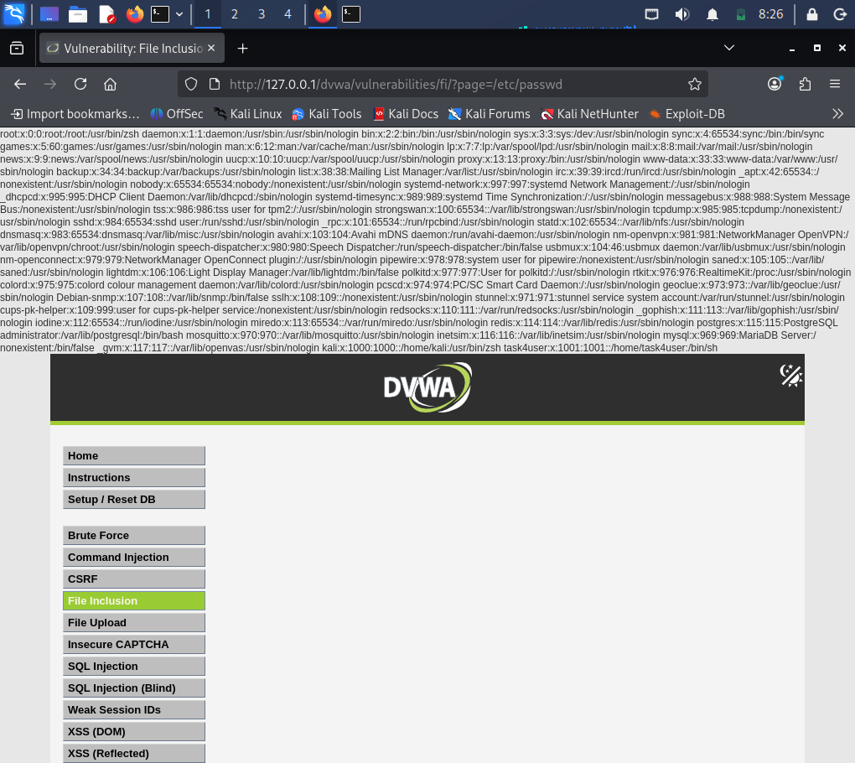
Security Impact
LFI can expose sensitive system information and, depending on the application configuration and available files, may potentially lead to more serious compromise.
Mitigation
LFI can be prevented by avoiding direct use of user-controlled file paths, implementing strict allowlists for permitted files, validating and canonicalizing paths, and preventing directory traversal. Sensitive files should also have appropriate operating-system permissions.

10. Web Security Headers
HTTP security headers provide additional protection against common web-based attacks by instructing browsers how web content should be handled.
The DVWA response was inspected using the browser's developer tools and the Network section. The HTTP response headers were examined to understand the security configuration of the web application.
Important security headers that can be configured for web applications include:
- Content-Security-Policy (CSP)
- X-Content-Type-Options
- X-Frame-Options
- Strict-Transport-Security (HSTS)
- Referrer-Policy
- Permissions-Policy
Importance
Security headers can help reduce risks such as Cross-Site Scripting, clickjacking, MIME-type sniffing, information leakage, and other browser-based attacks. They should be configured according to the requirements of the application and deployment environment.
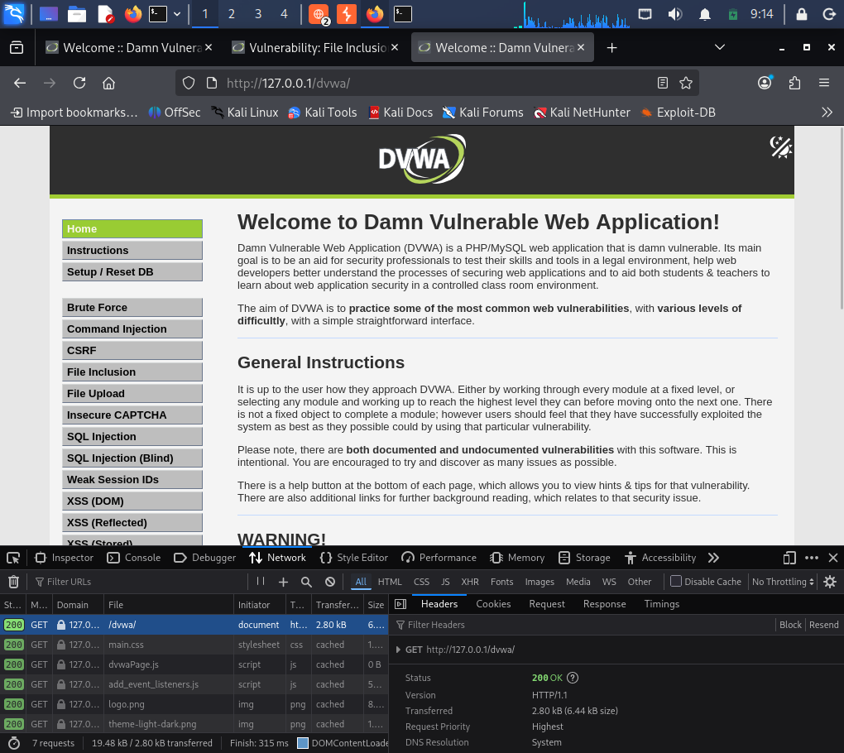

11. Security Recommendations
Based on the vulnerabilities demonstrated during the practical exercises, the following security recommendations should be implemented:
- Use prepared statements and parameterized queries to prevent SQL Injection.
- Validate and sanitize all user-supplied input.
- Apply context-aware output encoding to prevent XSS.
- Implement a strong Content Security Policy.
- Use anti-CSRF tokens for state-changing operations.
- Use secure cookie attributes such as HttpOnly, Secure, and SameSite where appropriate.
- Avoid directly using user-controlled file paths for file inclusion.
- Use allowlists for files that an application is permitted to access.
- Configure appropriate HTTP security headers.
- Follow the principle of least privilege for database and application accounts.
- Perform regular vulnerability assessments and security testing.
- Follow secure coding practices throughout the application development lifecycle.
Applying these controls can significantly reduce the attack surface of web applications and improve their overall security posture.

12. Conclusion
This task provided practical experience in identifying and understanding common web application security vulnerabilities using DVWA in a controlled Kali Linux environment. SQL Injection, Stored XSS, Reflected XSS, CSRF, and Local File Inclusion were demonstrated to understand how insecure application behavior can be exploited.
The exercises also demonstrated the importance of secure development practices such as parameterized SQL queries, input validation, output encoding, CSRF tokens, secure file handling, and HTTP security headers.
Overall, the practical work improved understanding of web application attack surfaces, vulnerability identification, security impact, and defensive techniques. The controlled DVWA environment provided a safe platform for learning web application penetration-testing concepts without affecting real-world systems.

